4.1 Testing

This section will guide you to:

* Run unit tests in Angular apps

This lab has three subsections, namely:

4.1.1 Creating a new Angular project

4.1.2 Writing one Unit Test

4.1.3 Running the DOM Element check spec file

**Step 4.1.1:** Creating a new Angular project

* Open the terminal and navigate to a directory you would like to code in
* Run the command, *ng new test-app*
* Once the command finishes execution, navigate into the test-app directory using the command *cd test-app*
* The app was created with test cases written in the *app.component.spec.ts* file. Run the command *ng test* to run the test
* A browser window will open and show that the test was passed as shown below

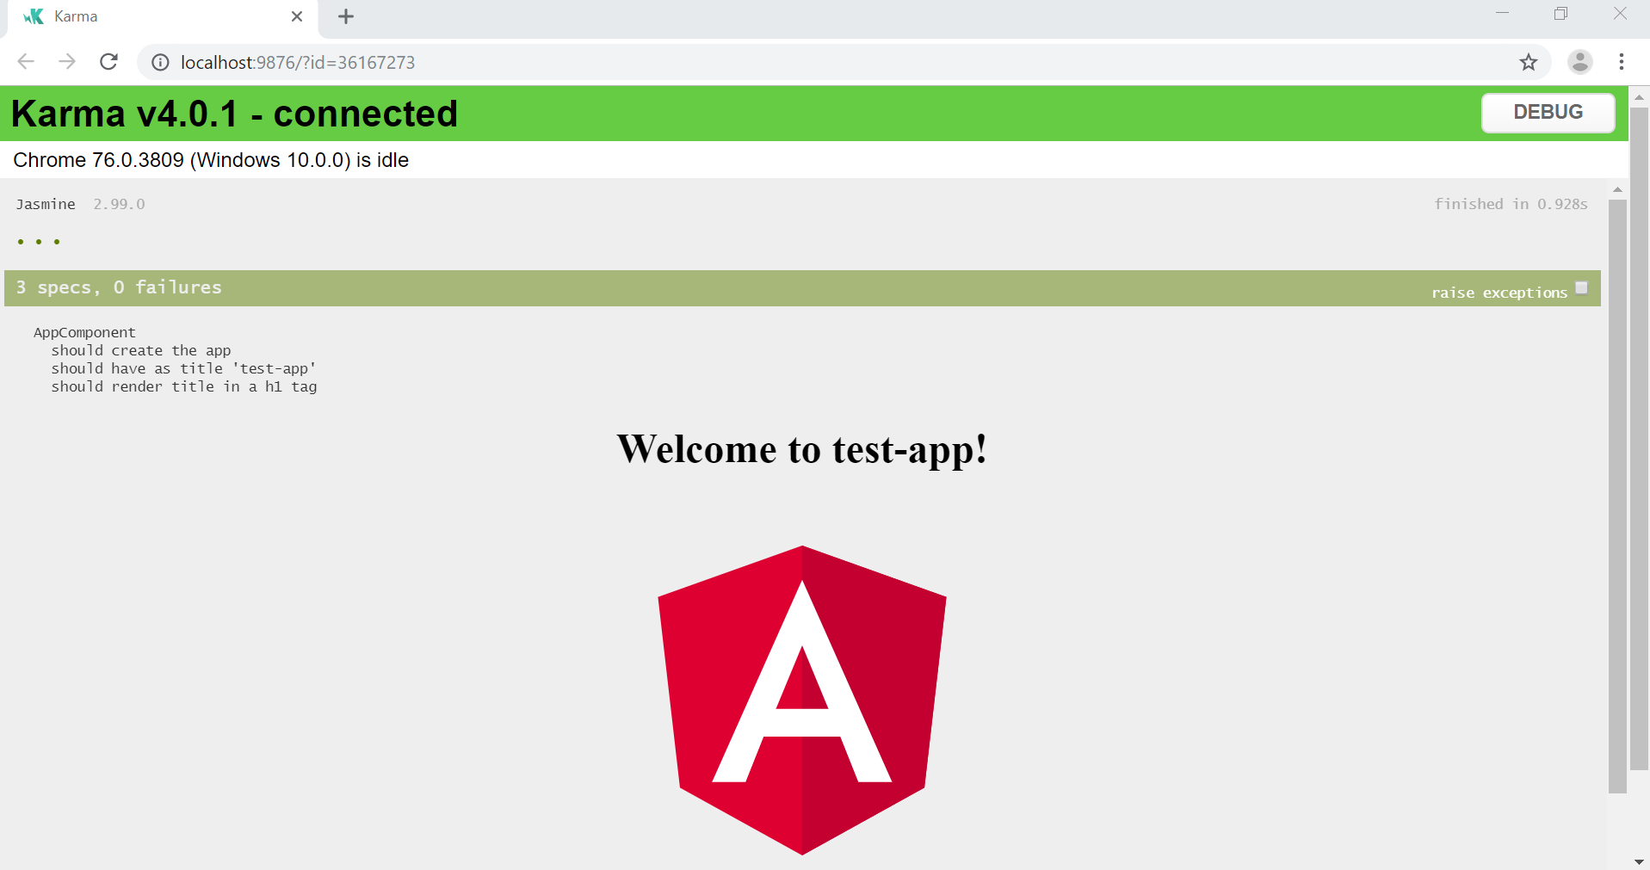

**Step 4.1.2:** Writing one Unit Test

* Run the command *ng g c dash* to create a new component
* Navigate to the newly created dash folder within the app folder inside the src folder
* Open the dash.component.ts file
* Enter the code below and save the file

**import { Component, OnInit } from '@angular/core';**

**@Component({**

**selector: 'app-dash',**

**templateUrl: './dash.component.html',**

**styleUrls: ['./dash.component.css']**

**})**

**export class DashComponent implements OnInit {**

**title = 'dash';**

**constructor() { }**

**ngOnInit() {**

**}**

**}**

* Open the dash.component.spec.ts file
* Enter the code below inside the *describe()* function and save the file

**it(`should have as title 'dash'`, async(() => {**

**fixture = TestBed.createComponent(DashComponent);**

**component = fixture.debugElement.componentInstance;**

**expect(component.title).toEqual('dash');**

**}));**

* Run the command *ng test* to run the test
* A browser window will open and show that the test was passed as shown below

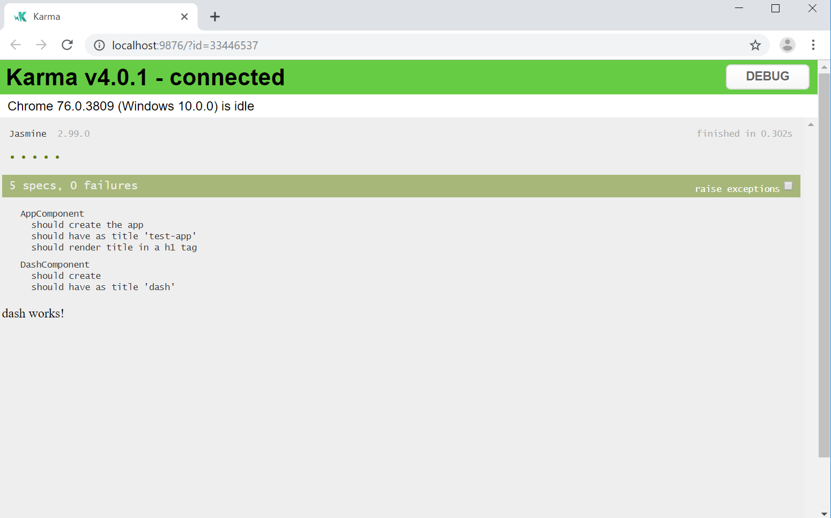

**Step 4.1.3:** Running the DOM Element check spec file

* Open the dash.component.spec.ts file in your code editor
* Add the following import statement to the top of the code

**import { DebugElement } from '@angular/core';**

**import { By } from '@angular/platform-browser';**

* Enter the code below inside the *describe()* function and save the file

**it('should have a h1 tag of `dash works!`', () => {**

**let de: DebugElement = fixture.debugElement; expect(de.query(By.css('p')).nativeElement.innerText).toBe('dash works!');**

**});**

* Run the command *ng test* to run the test
* A browser window will open and show that the test was passed as shown below

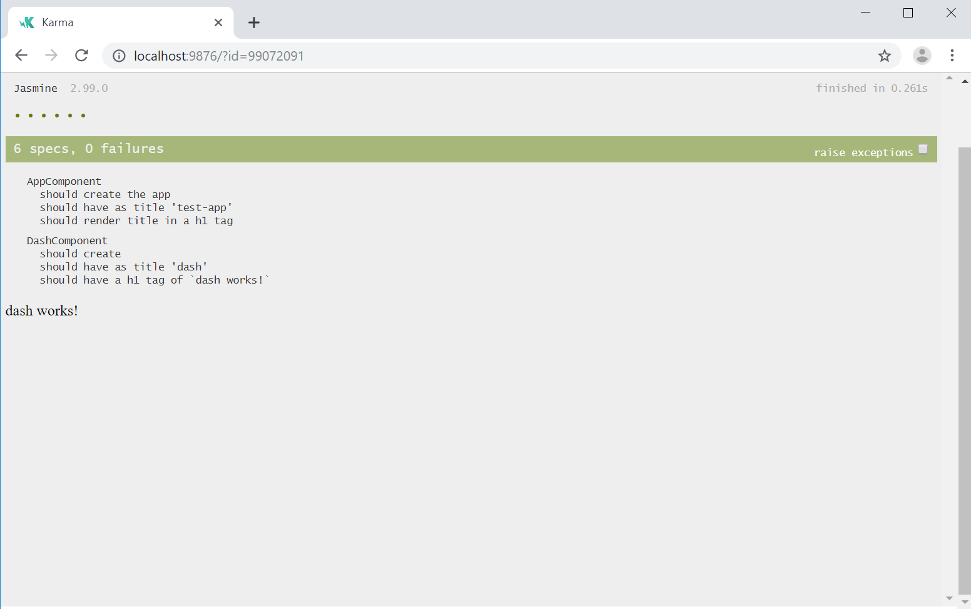

* Open the file *dash.component.html* in your code editor
* Remove the line *dash works* and save the file
* Run the command *ng test* to run the test
* A browser window will open and show that the test failed as shown below

